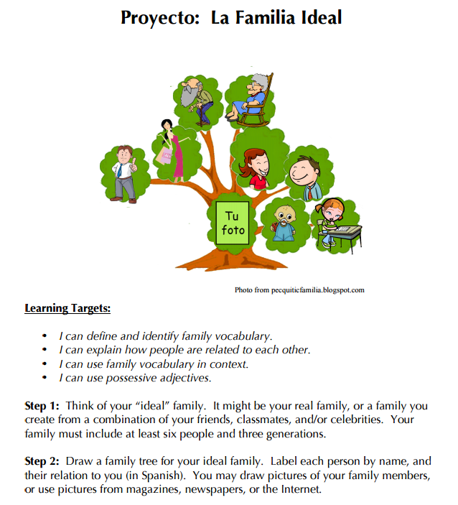
Step 3:
Write 3 sentences for each family member. We will be working on this over the next few classes.
Day 1: How is this person related to you? Guide: Mi (family vocabulary word) es (name of person).
Day 2: Tell what your family member’s personality and appearance are like using 2 adjectives from class. Guide:
Mi (family member) __adjective___ y ___adjective___. (Do we use es or está for describing personality?)
Day 3: Tell how your family member is feeling. Guide: Mi (family member) ___emotion____. (Do we use es or está for describing emotions?)

